The 4+1 View

# **X Use Case View for End users**

Use case Diagram

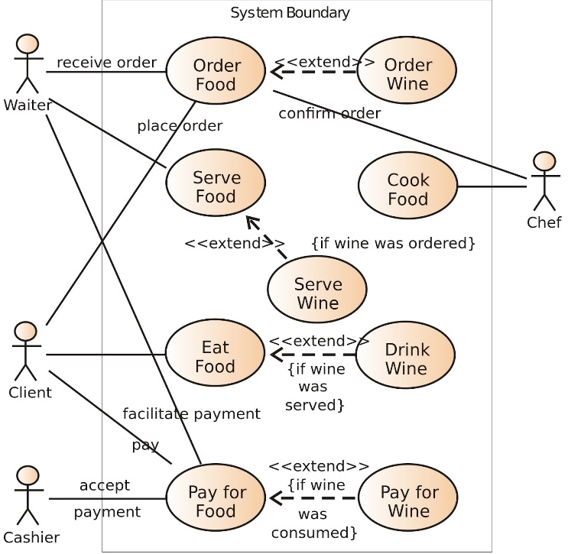

# **X Structural View for Analysts and Designers**

Conceptual – Functional   
Stage: Requirement analysis  
Focus: Object oriented decomposition  
Concerns: Functionality

Class Diagram

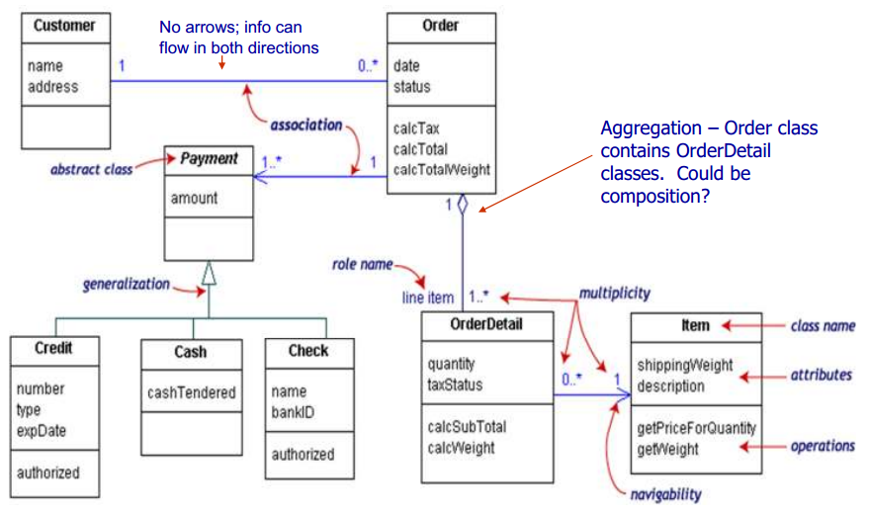

# **X Implementation View for Developers and Project Managers**

Physical – Functional:   
Stage: Design  
Focus: Subsystem decomposition  
Concerns: Software management

Package Diagram

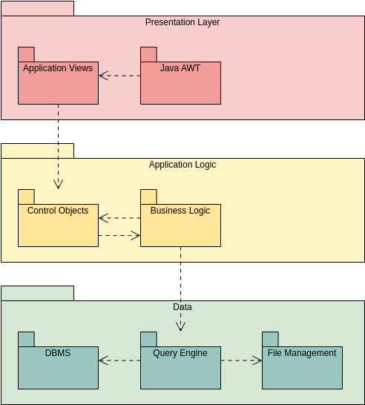

# Process View for System Integrators

Physical Non-functional  
Stage: Design  
Focus: Process decomposition  
Concerns: Performance, scalability, throughput

Sequence Diagram  
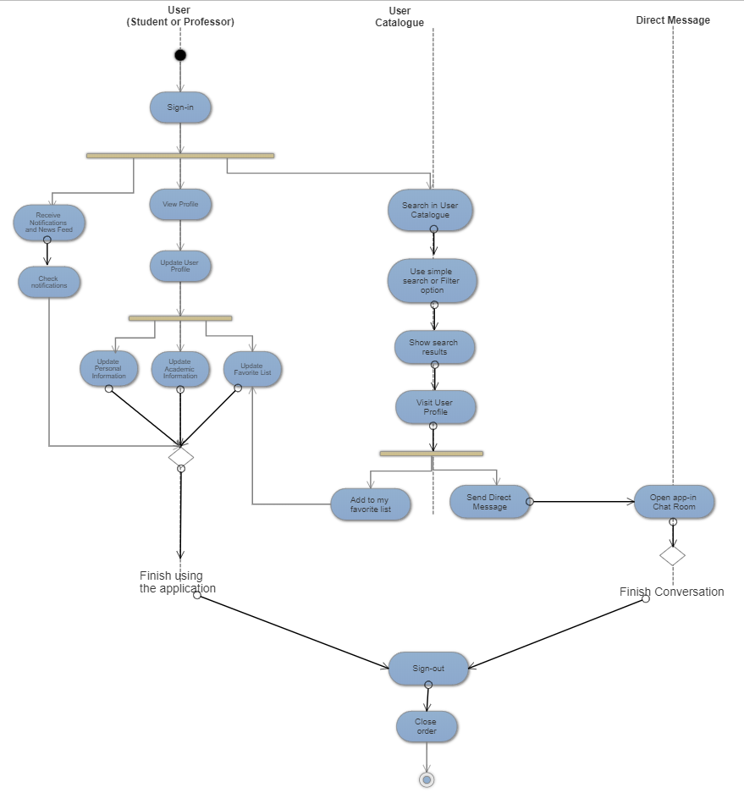

# **X Physical deployment View for System Engineers**

Physical non-functional  
Stage: Design  
Focus: Map software to hardware  
Concerns: System topology, delivery, installation, communication

Deployment diagram

